Specific Requirements

External Interface Requirements
This section contains the requirements and characteristics of the user interface specified by the client. This sections describes the external and behavioral requirements of the propose system. A scientist and a guest user will have identical external capabilities; however the scientist will have additional features to interact with the system.

General User Interfaces
- All windows shall include a minimize button, a maximize button, and a close button at the top right corner.

Wizard Training Guide
- The system shall have a training guide for users on how to use the system.
- The system shall display a text window on how to specify a scope.
- The system shall display a text window on how to specify a pattern.
- The system shall display a text window on how to save a data property.
- The system shall display a text window on how to set-up an alert notification.
- The system shall display a text window on how to select a sensor.

Map Screen

Tracking
- The system shall display the sensor’s name.
- The system shall display sensor’s location on a map.
- The system shall display the type of measurement a sensor is measuring.

Sensor
- Pending verification from the client. The system shall display the sensor’s description.
- Pending verification from the client. The system shall display the sensor’s GPS coordinates.
- Pending verification from the client. The system shall display the sensor’s manufacturer.
- Pending verification from the client. The system shall display the sensor’s serial number.
- Pending verification from the client. The system shall display the sensor’s measurement type.
- Pending verification from the client. The system shall display the sensor’s model.
- Pending verification from the client. The system shall display the sensor’s measurement range aka footprint: smallest and largest values.
- Pending verification from the client. The system shall display the sensor’s data-type.

Data Properties
- A data property shall be composed of a scope and pattern.
- The system shall let the user to define and modify properties.
- The system shall create an alert (email alert and/or cellular text message) when data is outside the user’s specified data property to inform the user when an anomaly occurs.
- The system shall keep track of which user initially created a property by including an author field that is associated with the data property when it is created and saved.
- The system shall store a revision history of the changes done to a data property.
- The system shall keep track of three kinds of data; data that is coming off the sensors, data properties, and anomalies.
- The system shall allow a user who initially created the data property to grant other authorized users access and to view a data property.
- The system shall allow the user set the frequency of which the data stream measures in minutes, seconds, hours, or microseconds.
- The system shall allow a user to download visual graphs; line and bar graph.
- The system shall allow a user to print a visual graph; line and bar graph.
- The system shall allow data properties to be displayed in a graphical representation: line or bar graph.
- The system shall inform a user when units are not the identical when applying data properties.
- The system shall display appropriate units based on the datasets. (For instance, humidity = percentage, temperature = Celsius)
- The system shall store the user’s name and date that modified a data property.
- The system shall display a list of public data properties from other users for other users to view, modify and edit.
- The system shall list anomalies associated with the data property.
- The system shall allow an author of the data property to delete it.

Preference
- The system shall store which user generated the data as well as the position, institution, and contact information.
- The system shall allow the user to designate their properties as public or private, public meaning anybody can view the property, or private which is restricted access.
- The system shall allow properties to be able to be applied to collected historical data.
- The system shall allow the user to choose the type of notification they would prefer, from email or mobile alert.

Hardware Interfaces
Requirements have not been specified.

Software Interfaces
- Application will run Windows Operations System and Mac.

Communications Interfaces
Requirements have not been specified.

Behavioral Requirements

Same Class of User
The system has two types of users, the scientist and the general public. Scientist has access to all the features of the system.
- The system shall have two levels of privileges: Registered User and Guest User.
- Registered – Scientist who are registered in the system
- Guest User – General public, Citizen Scientist
- The system shall have a login window for registered user.
- Registered user shall have access to all features of the system.
- General public shall be able to view public data properties.

Objects
The object model for our system is provided in Appendix A. The class diagram depicts the entities modeled by the system and the relationships among them. This section describes the requirements related to the main objects of the system.

Stimulus
The state chart model for our system is provided in Appendix B.

Related Features
- The system shall have users with restricted access that will not be able to create/edit properties.
- The system shall have an administrator that will be managing the data and the properties.
- The system shall inform the user about the precision and accuracy of the sensor measurement.

Functional
Functional requirement specify actions in the system. This includes accepting and processing inputs and generating results for the user. A data flow can demonstrate the relationships between the functions and data input. A data flow diagram is provided in Appendix B to demonstrate the main use of the system.

- The system shall require users to have their credentials validated before granting them access to the system.

Scope
- The system shall allow for global scopes to be used for analysis which includes a year range of the available data
- The system shall allow for the user to view data before a specific event declared by the user to happen also known as before R.
- The system shall with the ‘after L’ include the data readings where L holds.
- The system shall with the ‘before L’ does not include the data readings where R holds.
- The system shall with the ‘between L & R’ includes the reading at point L but does not include the reading for point R.
- The system shall with the ‘after L until R’ include the readings between the first L all the way until R before the first R otherwise the system will include all the readings after L.
- The system shall with ‘universality between L & R’ readings after L and before R have to hold.
- The system shall allow a scope to be built once L is specified.

Pattern
- The system shall with the ‘absence’ pattern the readings in the scope should never hold.
- The system shall with the ‘existence’ pattern the readings should hold at least once in the scope.
- The system shall with the ‘response’ pattern present two graphs.

Data Properties
- The system shall allow the user to view the information that states what error was caused when a problem or anomaly was raised and will include the data property that was used and the data set is associated with the data property.
- The system shall allow the user to view the description of the property of an error caused when a problem or anomaly was raised and will include the data property that was used and the data set is associated with the data property.
- The system shall allow the user to view the information that states the data that it’s being generated by the sensor related to an error caused when a problem or anomaly arises using a mobile phone.
- The system shall allow the user to view the information that states what error was caused, the description of the data property, and the data that it’s being generated by the sensor in relation to an error caused when a problem or anomaly arises using a mobile phone. The view mode should be using a graph tool.
- The system shall provide the data property on any alert generated by an anomaly.
- The system shall allow users to reuse data properties and save it as their own.
- The system shall allow the ability to edit data properties.
- The system shall allow comparison between different sensors for relation pattern.
- The system shall allow a scientist to enable or disable an anomaly alert.

File Format
- The system shall take the different sensor file formats and convert them to a system-standardized format for analysis.
- The system shall store newly created file formats to be used to parse new types of data files coming from new sensors.

Non Functional
- The system shall be accessible through a web site.

Non-behavioral Requirements

Performance Requirements
<< This subsection should specify both the static and the dynamic numerical requirements placed on the software or on human interaction with the software as a whole. Static numerical requirements may include:
- the number of terminals to be supported,
- the number of simultaneous users to be supported, and/or
- the amount and type of information to be handled.
Dynamic numerical requirements may include, for example, the numbers of transactions and tasks and the amount of data to be processed within certain time periods for both normal and peak workload conditions. All of these requirements should be stated in measurable terms, e.g.,
“95% of the transactions shall be processed in less than 1 second.”
rather than,
“An operator shall not have to wait for the transaction to complete.” >>

Qualitative Requirements
<< There are a number of attributes of software that can serve as requirements. It is important that required attributes be specified so that their achievement can be objectively verified. >>

Availability
<< This should specify the factors required to guarantee a defined availability level for the entire system such as checkpoint, recovery, and restart. >>

Security
<< This should specify the factors that will protect the software from accidental or malicious access, use, modification, destruction, or disclosure. Specific requirements in this area could include the need to:
- utilize certain cryptographical techniques,
- keep specific log or history data sets,
- assign certain functions to different modules,
- restrict communications between some areas of the program, and/or
- check data integrity for critical variables. >>

Maintainability
<< This should specify attributes of software that relate to the ease of maintenance of the software itself. There may be some requirement, for example, for certain modularity, interfaces, or complexity. Requirements should not be placed here just because they are thought to be good design practices. >>

Portability
<< This should specify attributes of software that relate to the ease of porting the software to other host machines and/or operating systems. This may include the following:
- percentage of components with host-dependent code,
- percentage of code that is host dependent,
- use of a proven portable language,
- use of a particular compiler or language subset, and
- use of a particular operating system . >>

Design and Implementation Constraints
<< This should specify design constraints that can be imposed by other standards or hardware limitations. This may include standards compliance, which state requirements derived from existing standards, or regulations (e.g., report format, data naming, accounting procedures). This section details constraints that directly affect design and implementation. For example:
“The software shall be developed in Java 1.2” or
“The number of entries in the Log Table shall not exceed 500 entries.” >>

Other Requirements

Database

Operations
<< This section should specify the normal and special operations required by the user, such as:
- the various modes of operation in the user organization, e.g., user-initiated operations,
- periods of interactive operations and periods of unattended operations,
- data processing support functions, and
- backup and recovery operations. >>

Site Adaptation
<< This section could be used to:
- define the requirements for any data or initialization sequences that are specific to a given site, mission, or operational mode, for example, grid values, or safety limits, and
- specify the site or mission-related features that should be modified to adapt the software to a particular installation. >>

Appendix A Class Diagram

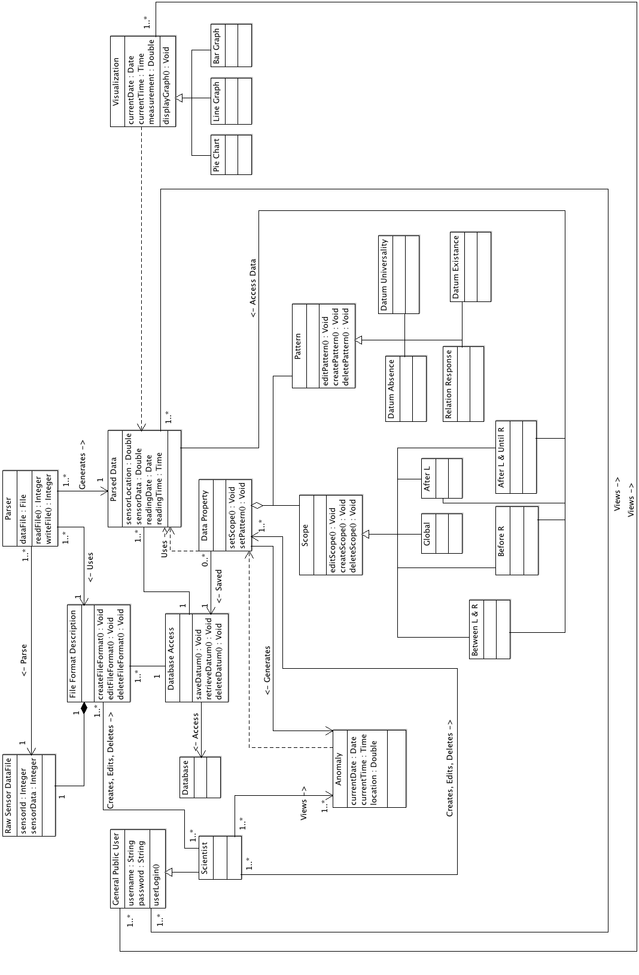

Appendix B State Chart
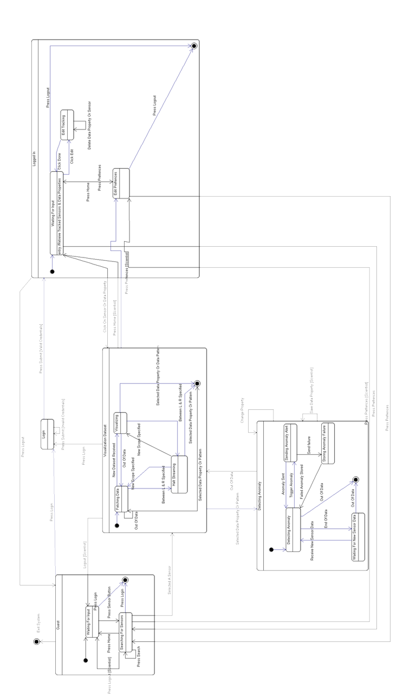

Appendix C Data Flow Diagram (DFD)




